REPORT ON SELECT COMMITTEE'S PUBLIC CONSULTATION ON
THE KERALA FARMERS’ WELFARE FUND BILL, 2018
JULY 19, 2019, THODUPUZHA

The Kerala Legislative Assembly’s Select Committee hosted a ‘public consultation’ meeting at Thodupuzha Town Hall on the 19th July 2019, to deliberate the changes required in the Kerala Farmers’ Welfare Fund Bill, 2018.

Inaugurating the Session, the Hon’ble Agriculture Minister V S Sunilkumar (Chairman of the Select Committee on Kerala Farmers’ Welfare Fund Bill,2018) said that the purpose of the hearing is to seek and incorporate inputs of the relevant stakeholders before the Bill is finalized.

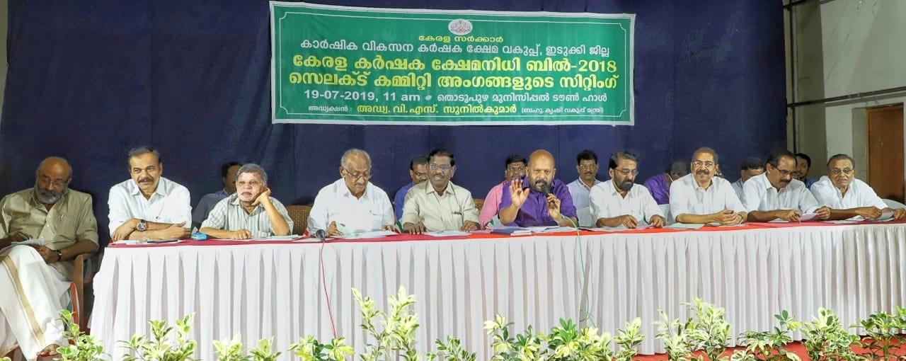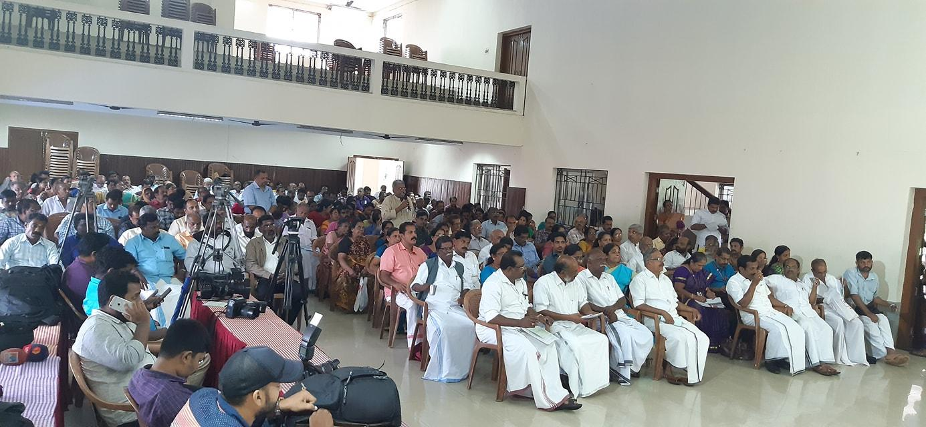

The meeting was attended by farmers, organisations working for the welfare of farmers and agricultural labourers, social workers etc. who deposed before the Committee and suggested changes to the present policy framework.

The event was dominated by complaints even after multiple reminders from Minister’s side on restricting the discussion to the contents of the Bill.

At this juncture, the Committee found the Chamber’s submission relevant and appreciated the clause wise submissions submitted by the Chamber. The Select Committee was requested to consider the clause wise comments for institutionalising a comprehensive legislation for farmers welfare in the ten minute slot given for individual speakers. The opportunity given was also utilised to highlight the need for expediting the much awaited ‘Plantation Policy’ and the need for extending welfare facilities like schools, hospitals etc. to the plantation workers.

Overview of responses

- Increase the income, land limit requirement in the definition of the word “farmer”.

- Better clarity required in the definitions of the words “agriculture” , “family”, “non-official director”, “allied-sectors” , “expert” etc.

- Constitution of the Board should be explained properly detailing the process of selection of the 9 farmer members, inclusion of other non-official members working in the agriculture sector etc.

- Special package and/or policy for the plantation sector.

- Defining the pension amount.

- Extending low premium insurance for plantation crops.

- Create regular awareness initiatives to promote the implementation of crop insurance schemes instituted by the Government.

- Initiate health insurance for farmers and their dependents.

- Make Government Offices farmer friendly.

- Facilitate reforms that promote youth in taking up farming as a means of livelihood

- Incorporate modules on farming in school syllabuses

- Efficient functioning of Krishi Bhavans and Procurement Centers

- Need for better coordination between various Government Agencies and Voluntary Organizations working for the welfare of farmers

`````````````````````````

