About Sudakshna Thampi
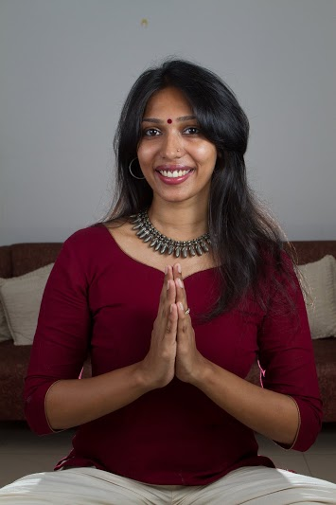
Sudakshna Thampi , is a Hatha yoga practioner, who did her training from the hub of yoga , Mysore. She studied yoga at the Samyak Yoga ashram , at the spiritual banks of Cauvery Sannidhi. She is internationally certified as a Yoga Alliance registered teacher.
Her yoga venture is called Instant Yogi. It is yoga for the urban being. With enough practice, it is possible to be ‘yogic’ and at peace at every instant. By learning to stay centred and balanced through yoga pranayama and meditation , it is possible to strive towards being the best possible version of yourself.
In a short span , she has touched the lives of many. She has a wide range of experience from training Miss Asia contestants in body wellness to organizing and leading mass yoga events with a thousand people attending.

Her articles and interviews have been published in National and vernacular magazines and papers such as Business World , Vanitha , The Hindu , Malayala Manorama , Mathrubhumi, Indian Express , Times of India etc. She has also appeared in many interviews in all the local channels and radio. Her focus is on spreading knowledge on healthy lifestyles - exercise and nutrition - to prevent and control lifestyle related disease. She conducts daily morning classes , corporate trainings , yoga for events , retreats and offsites in Kochi , Kerala. You can follow her on Instagram on @sudakshnat. Videos to watch View here and Sample Videos – click here or here

